New Delhi, India

July 16, 2024

FUNCTIONAL REquirement SPECIFICATION

*GEG MIS Expansion to include EmpowerU, PROSPECTS and G4DU*

**Revision History**

|  |  |  |  |
| --- | --- | --- | --- |
| Name | Date | Reasons of Changes | Version |
| iTM | 16 July 2024 | The first draft of FRD developed. | V1 |

Table of Contents

Overview 3

The Platform 3

Functional Requirements 4

1.1 Pre-Registration 5

Export Data 5

Import Data 6

1.2 Registration 7

Export Data 13

Import Data 14

1.3 Reports 15

1.4 At a Glance 16

1.5 Admin 17

1.5.1 Cohort 17

1.5.2 Master List 20

ANNEXURE - Diagrams and Flow Charts 1

# Overview

This Functional Requirements Document (FRD) describes a software system and its component. It helps to capture the intended behavior and capabilities of the GEG MIS Extension that can be agreed upon by the team. It will capture a list of requirements statements organized by the extended features of the GEG MIS platform with identified priorities.

It will further ensure that the team working on the project fully understands the requirements and is concentrating their efforts to develop a solution that will satisfy the expected results.

# The Platform

The **Girls Empowering Girls (GEG)** Management Information System is developed for data collection, management, and visualization of data to support better decision making for cash transfer on the GEG programs. The data is stored centrally to help presenting the data effectively. This system provides support to manage the data of in school and out-of-school adolescent girls living in Kampala, manage a network of peer and lead mentors and cash transfer information to ensure, all project information, which has been collected and managed offline, in different places, is brought together to facilitate real time monitoring and reporting on the project for better decision making on GEG programme.

Below sections explains the detailed functional requirement of each module of the extended GEG MIS platform.

# Functional Requirements

The platform comprises of various independent modules. These modules have interconnection to ensure the user navigation is seamless from one module to another.

Below is the list of all the modules -

1. Home Page
2. About
3. Information Kiosk
4. Login
   1. Pre-registration
   2. Beneficiary
      1. Profile
      2. Cash Transfer
      3. Mentoring
      4. Referral
      5. Grievance / Complaint
   3. Admin
      1. Cohort
      2. Area
      3. User
      4. Resource
      5. Master List
      6. Log
      7. Audit Trail
   4. Reports

The detailed functional requirements of the modules that need updates as per the scope are explained below.

## Pre-Registration

**Description and Priority**

This module allows administrator to Add, Edit, Delete and View the potential candidates that can be selected as beneficiaries of the program. There is option for the administrator to move the girl as a beneficiary from the pre-registration list. Below is the extended requirement of the Pre-registration module.

**Functional Requirements**

|  |  |
| --- | --- |
| BR 1.1.1 | When adding a new element, provide the following entries and validations –   * **First Name** of the girlshould be entered and cannot be blank. * **Last Name** of the girlshould be entered and cannot be blank. * **Other Name** of the girlshould be entered. |

### Export Data

This option will be available to download the data file to enter pre-registration details for multiple beneficiaries at once.

**Functional Requirements**

|  |  |
| --- | --- |
| BR 1.1.2 | Provide an option to download the template with the columns: First Name, Last Name, Other Name, DOB, Age, Division, School, Parish, Village, EducationCategory, SchoolStatus, YearDropped, VulnerabilityChildMother, VulnerabilityPregnant, VulnerabilityDisability, VulnerabilityOther, VulnerabilityOtherText, CaretakerFirstName, CaretakerLastName, CaretakerOtherName, CaretakerContact. |

### Import Data

Bulk import pre-registration details of multiple beneficiaries in the database. The Import Data option allows to:

* Browse and upload data template
* Import the data template into the database

**Functional Requirements**

|  |  |
| --- | --- |
| BR 1.1.3 | Import the data entry records with the following validations:   * All the validations applied for each field while adding a beneficiary for pre – registration using form date entry will also be implied while importing the same details into the database. * Combination of all the columns cannot be duplicate. * Overwrite the old data with new data when a duplicate entry will be found. * Name, Date of birth, Age, and other details cannot contain any special character. |
| BR 1.1.4 | Show error message “Invalid File Format” if the above requirements are not met. |

## Registration

**Description and Priority**

This module is the core module of the platform. It is accessible to all the users of the platform but the actions are based on their roles and permissions. This module allows to register girls enrolled in pre-registration process as final participant of the GEG programme and allow the users to view and manage the participants which are assigned to them. Below is the extended requirement of the Registration module.

**Functional Requirements**

|  |  |
| --- | --- |
| BR 1.2.1 | Provide the option to **Search** and **Advance Search** the beneficiary using ID, First Name, Last Name, Other Name, School category, and Location when adding a new participant in pending state. |
| BR 1.2.2 | Provide the option to **Verify NIN** in the action column of each participant with the following validations –   * The Verify NIN option should be disabled for the participant who do not have an NIN number. * Check ID, First Name, Last Name and Other Name (if exist) from NSR when clicked on Verify NIN * Show message on the successful verification of NIN. * Show message on the failure of NIN verification. |
| BR 1.2.3 | Provide a column **NIN Status** in the table grid that will show the verification status of the NIN of each participants. |
| BR 1.2.4 | Provide an option to **Approve** in the action dropdown of the participants with following validations –   * The Approve option will be disabled for the participants whose NIN exist but is not verified. * The Approve option will be enabled for the participants whose NIN does not exist. * The Approve option will be enabled for the participants whose NIN exist and is verified. |
| BR 1.2.5 | If approved, move the participant to approve list from pending and allow performing following action in the Approved state –   * Edit * Exit |
| BR 1.2.6 | When editing an element, provide a dropdown to select one of the following category –   * School Status * Transition Details * Skill and Business * Disability * Vulnerability * Participant Personal Details * Caretaker Details |
| BR 1.2.7 | *When editing SCHOOL STATUS, provide the following entries and validations -*  **In case of ISG -**   * Provide an Education Category dropdown with options - In School and Out of School. * By default, show In school option selected in the Education Category dropdown. * Allow updating school status from "In School" to "Out of school”   **In case of OOSG -**   * Provide an Education Category dropdown with options - In School and Out of School. * By default, show Out of School option selected in the Education Category dropdown. * Allow updating school status from "Out of school" to "In School" * Provide option to Select Division * Provide option to Select School * Provide option to Select Class   Provide an **Update** button to save the changes. |
| BR 1.2.8 | *When editing TRANSITION STATUS, provide the following entries and validations -*  **In case of ISG -**   * Provide a dropdown to select Transition Status as either Yes or No. * In case the Transition status is YES - * Provide a textbox to enter PLE Results and it cannot be blank * Provide a dropdown to select Secondary School and it cannot be blank * Provide a textbox to enter Class name and it cannot be blank. * In case the Transition status is NO - * Provide a textbox to enter PLE Results and it cannot be blank * Provide a radio button to select if participant has Repeated a class * Provide a radio button to select if participant has Joined vocational skill training   **In case of OOSG -**   * Provide a dropdown to select if participant is Back to school as either Yes or No. * If the Back to status is Yes - * Provide a dropdown to select Transition Status as either Yes or No * In case the Transition status is YES - * Provide a textbox to enter PLE Results and it cannot be blank * Provide a dropdown to select Secondary School and it cannot be blank * Provide a textbox to enter Class name and it cannot be blank.   Provide an **Update** button to save the changes. |
| BR 1.2.9 | *When editing SKILL and BUSINESS provide the following entries and validations -*   * Provide a dropdown with option as Yes and No to confirm taking up a Skill. * When Skill is selected as Yes - * Provide an option to select Skill Type and it cannot be blank. * Provide a dropdown with option as Yes and No to confirm is Training Completed and it cannot be blank. * Provide option to enter Remarks. * When Skill is selected as No - * Provide a dropdown with option as Yes and No to confirm taking up Business. * Provide option to enter Remarks (If Business is selected as Yes).   Provide an **Update** button to save the changes. |
| BR 1.2.10 | *When editing Disability Status provide the following entries and validations -*   * Provide a dropdown with option as Yes and No to confirm disability status. * 50 % top up should be given if the disability status is selected as Yes.   Provide an **Update** button to save the changes. |
| BR 1.2.11 | *When editing Vulnerability Status provide the following entries and validations -*   * Provide a dropdown option to select Vulnerability Status * 50 % top up should be given if the *Vulnerability* status is selected as Teenage pregnancy.   Provide an **Update** button to save the changes. |
| BR 1.2.12 | *When editing Participant details provide the following entries and validations -*   * Provide option to update NIN and Address of the participant. * When updating the NIN, Provide a Verify button to verify the updated NIN with NSR.   Provide an **Update** button to save the changes. |
| BR 1.2.13 | *When editing Caretaker details provide the following entries and validations -*   * Provide option to update NIN and Address of the participant. * When updating the NIN, Provide a Verify button to verify the updated NIN with NSR.   Provide an **Update** button to save the changes. |
| BR 1.2.14 | Provide **Exit** option in the action dropdown to move the participant in Exit list from Approved.   * When exiting participant provide an option to select **Reason** of Exit. |
| BR 1.2.15 | Provide option to add grievance and allow Admin and Program Officer to view all grievances. |
| BR 1.2.16 | Allow Admin and Program Officer to assign a specific user to the grievance when adding or updating a grievance. |

### Export Data

This option is available to download the data file to enter beneficiary details for bulk data records at once.

**Functional Requirements**

|  |  |
| --- | --- |
| BR 1.2.17 | Provide an option to download the template with the columns: First Name, Last Name, Other Name, DOB, Age, Division, School, Parish, Village, EducationCategory, SchoolStatus, YearDropped, VulnerabilityChildMother, VulnerabilityPregnant, VulnerabilityDisability, VulnerabilityOther, VulnerabilityOtherText, CaretakerName, CaretakerContact, CaretakerSex, Caretaker Relationship, CaretakerRelationshipDuratiuon, CaretakerAlternateContact, CaretakerNIN, CaretakerDivision, CaretakerParish, CaretakerVillage, CaretakerOccupation, StayingInSameHouse, CaretakerResponsibilities, AlternativeGuardian, AlternativeGuardianName,, AlternativeGuardianContact, BiologicalParentStatus, HouseholdHeadAgeStatus, Nationality, RefugeeStatus, CaretakerReceivedGEGPhone, PhoneSerialNumber, CaretakerReceivedGEGMTNsim, and RegGEGMTNline. |

### Import Data

This option is available to import bulk beneficiary details in the database. The Import Data option allows to:

* Browse and upload data template
* Import the data template into the database

**Functional Requirements**

|  |  |
| --- | --- |
| BR 1.2.18 | Import the data entry records with the following validations:   * All the validations applied for each field while adding a beneficiary using form date entry will also be implied while importing the same details into the database. * Combination of all the columns cannot be duplicate. * Overwrite the old data with new data when a duplicate entry will be found. * Name, Date of birth, Age, and other details cannot contain any special character. |
| BR 1.2.19 | Show error message “Invalid File Format” if the above requirements are not met. |

## Reports

**Description and Priority**

In the report sub-module, the administrator, partners and lead mentors will be able to select required report settings and download report based on the customized settings. Below is the extended requirement of the Reports module.

**Functional Requirements**

|  |  |
| --- | --- |
| BR 1.3.1 | Provide option to select one of the report types -   * Registration * Cash Transfer * Mentoring * Referral * Grievance |
| BR 1.3.2 | Allow to perform following settings to generate required report –   * Report **From** and **To** Date should be selected. * Report **Name** should be entered and it cannot be blank. * **Education Category** should be selected. * **Skill** should be selected *(Incase school category is Out of School).* * **Business** should be selected *(Incase school category is Out of School).* * **Transition to Secondary School** should be selected. * **Disability** should be selected. * **Division** should be selected. * **Parish** should be selected. * **Village** should be selected. * **School** should be selected. * Participant **Status** should be selected. |

## At a Glance

**Description and Priority**

This is the first view after successfully login. The summary data on mentors, cash transfer, referrals and complaints are presented in visually oriented interactive visualizations with options to filter data by Cohort, Area and Time period. Below is the extended requirement of the Dashboard module.

**Functional Requirements**

|  |  |
| --- | --- |
| BR 1.4.1 | Show the summary information on Mentoring, Cash transfer, Referral and Complaint in a separate widget with the help of visualizations. |
| BR 1.4.2 | Provide the count of Registered, Closed and Open grievances when clicking on the table icon available at the top right corner of the grievance widget. |
| BR 1.4.3 | Provide an option to view open grievances by participant and allow admin and program officer to assign user to the specific grievance. |

## Admin

This module is accessible only to the administrator and allows administrator to View, Add, Edit and Delete the master list of cohort, area, user, resource, log and audit trails available in the database.

### 1.5.1 Cohort

**Description and Priority**

In the cohort sub-module, the administrator is allowed to add and manage the cohort details in the platform. Below is the extended requirement of the Cohort module.

**Functional Requirements**

|  |  |
| --- | --- |
| BR 1.5.1 | Show the existing list of Cohort in tab view with following tab names -Pending, In-progress and Completed. Show the list in table grid by pages and provide option to set the number of records per page. |
| BR 1.5.2 | Provide options to search, sort and navigate the existing list. |
| BR 1.5.3 | Provide options to add and edit a cohort and its details in pending and in-progress state. |
| BR 1.5.4 | Provide option to delete a cohort and its details with following validations:   * Show the count of associated records and ask the user to confirm deletion. * Delete all the associated records after confirmation. |
| BR 1.5.5 | Provide option to show/hide a cohort and its details with following validations:   * Show/Hide the cohort and its details in both the applications. * Show/Hide all the associated records. * Do not allow data entry and data import for the hidden cohort. |
| BR 1.5.6 | Allow adding a new cohort and its details with the following validations -   * **Area** should be selected and it cannot be blank. * **Name** should be entered and it cannot be blank. * **Description** of Cohort should be entered. * **Start** **Year** should be selected and it cannot be blank. * **Last** **Date** of Registration should be entered and it cannot be blank. * Provide option to enter **Participant Details** (A popup window should open when clicked on participant details popup).   In participant details popup window, provide the following entries and validations -   * **Number of ISG registration** should be entered it and cannot be blank. * Installments amount of First Year ISG participants should be entered. * Installments amount of Second Year ISG participants should be entered. * Installments amount of Third Year ISG participants should be entered. * Installments amount of Fourth Year ISG participants should be entered. * Number of OOSG registration should be entered it and cannot be blank. * Installments amount of First Year OOSG participants should be entered. * Installments amount of Second Year OOSG participants should be entered. * Installments amount of Third Year OOSG participants should be entered. * Installments amount of Fourth Year OOSG participants should be entered. |
| BR 1.5.7 | Total Planned cost of cohort should be auto calculated based on participant installment amount details." |
| BR 1.5.8 | Provide an Add button to confirm adding a new cohort and its details. |
| BR 1.5.9 | Provide option to mark a pending cohort as Approve. |
| BR 1.5.10 | Provide option to mark a in progress cohort as Complete. |
| BR 1.5.11 | The registration of participants should only be allowed when the cohort is in In progress state. |

### 1.5.2 Master List

**Description and Priority**

In the master lists sub-module, the administrator is allowed to add and manage master lists of the platform. Below is the extended requirement of the Master List module.

**Functional Requirements**

|  |  |
| --- | --- |
| BR 1.5.1 | Provide option to select master list from following options:   * School * Referral * Complaint * Vulnerability * Responsibility * Occupation * Relationship * Skill * Business |
| BR 1.5.2 | Show the existing list of records and related information in a tabular grid based on the selected master list. Provide option to view the list by pages along with pagination option to customize the view. |
| BR 1.5.3 | Provide options to search, sort and navigate the selected master list. |
| BR 1.5.4 | Provide options to add and edit element to each master list. |
| BR 1.5.5 | Allow adding a new record in selected master list and its details with the following validations:  *In case adding a new record under* ***Skill*** *master list, Provide the following entries and validations –*   * Provide option to enter new *skill*. * No duplicate *relationship* should be added.   *In case adding a new record under* ***Business*** *master list, Provide the following entries and validations –*   * Provide option to enter new *business*. * No duplicate *relationship* should be added. |
| BR 1.5.6 | Provide the Add button in the add new element window to confirm adding the element. |

# ANNEXURE - Diagrams and Flow Charts

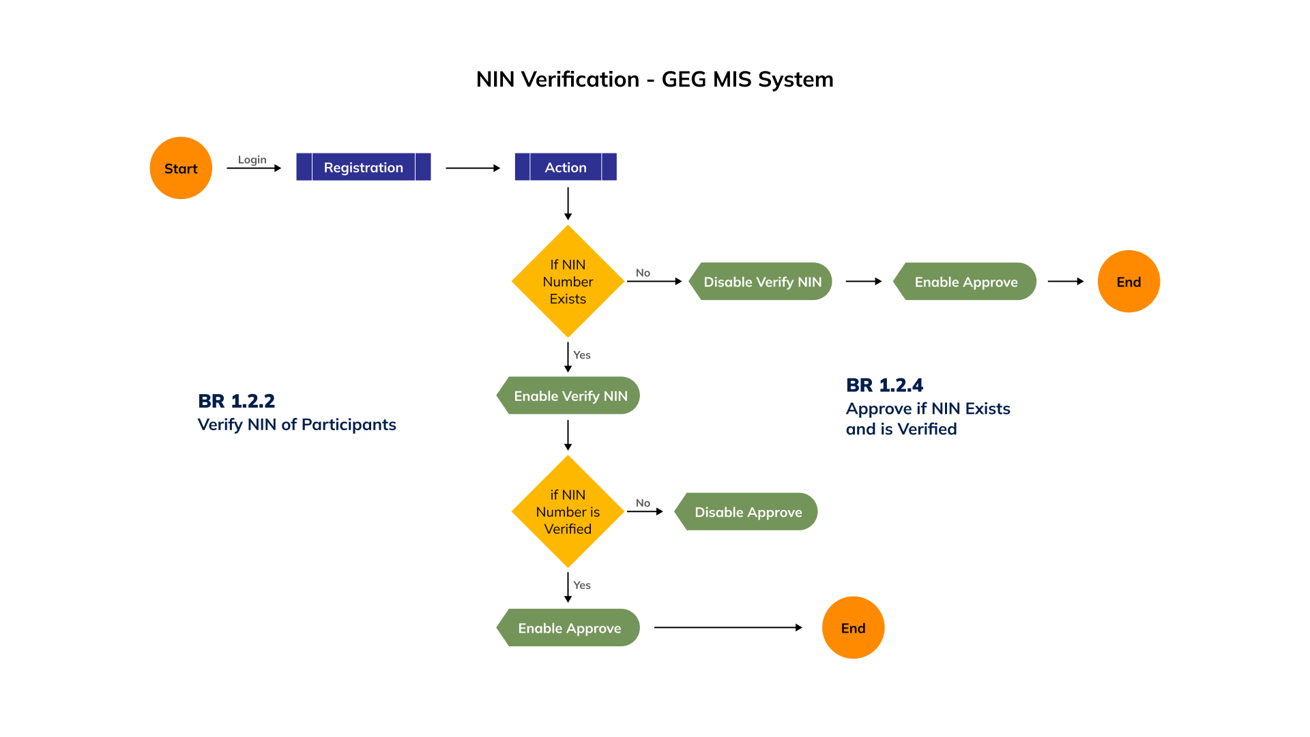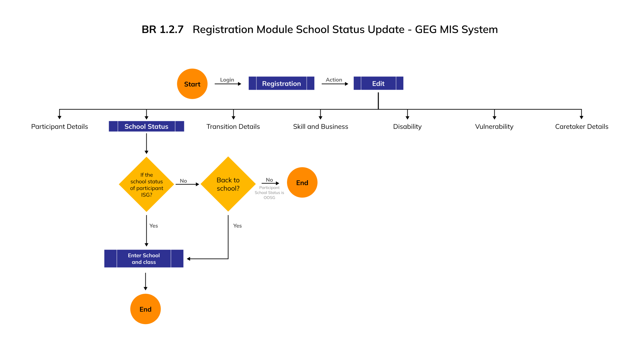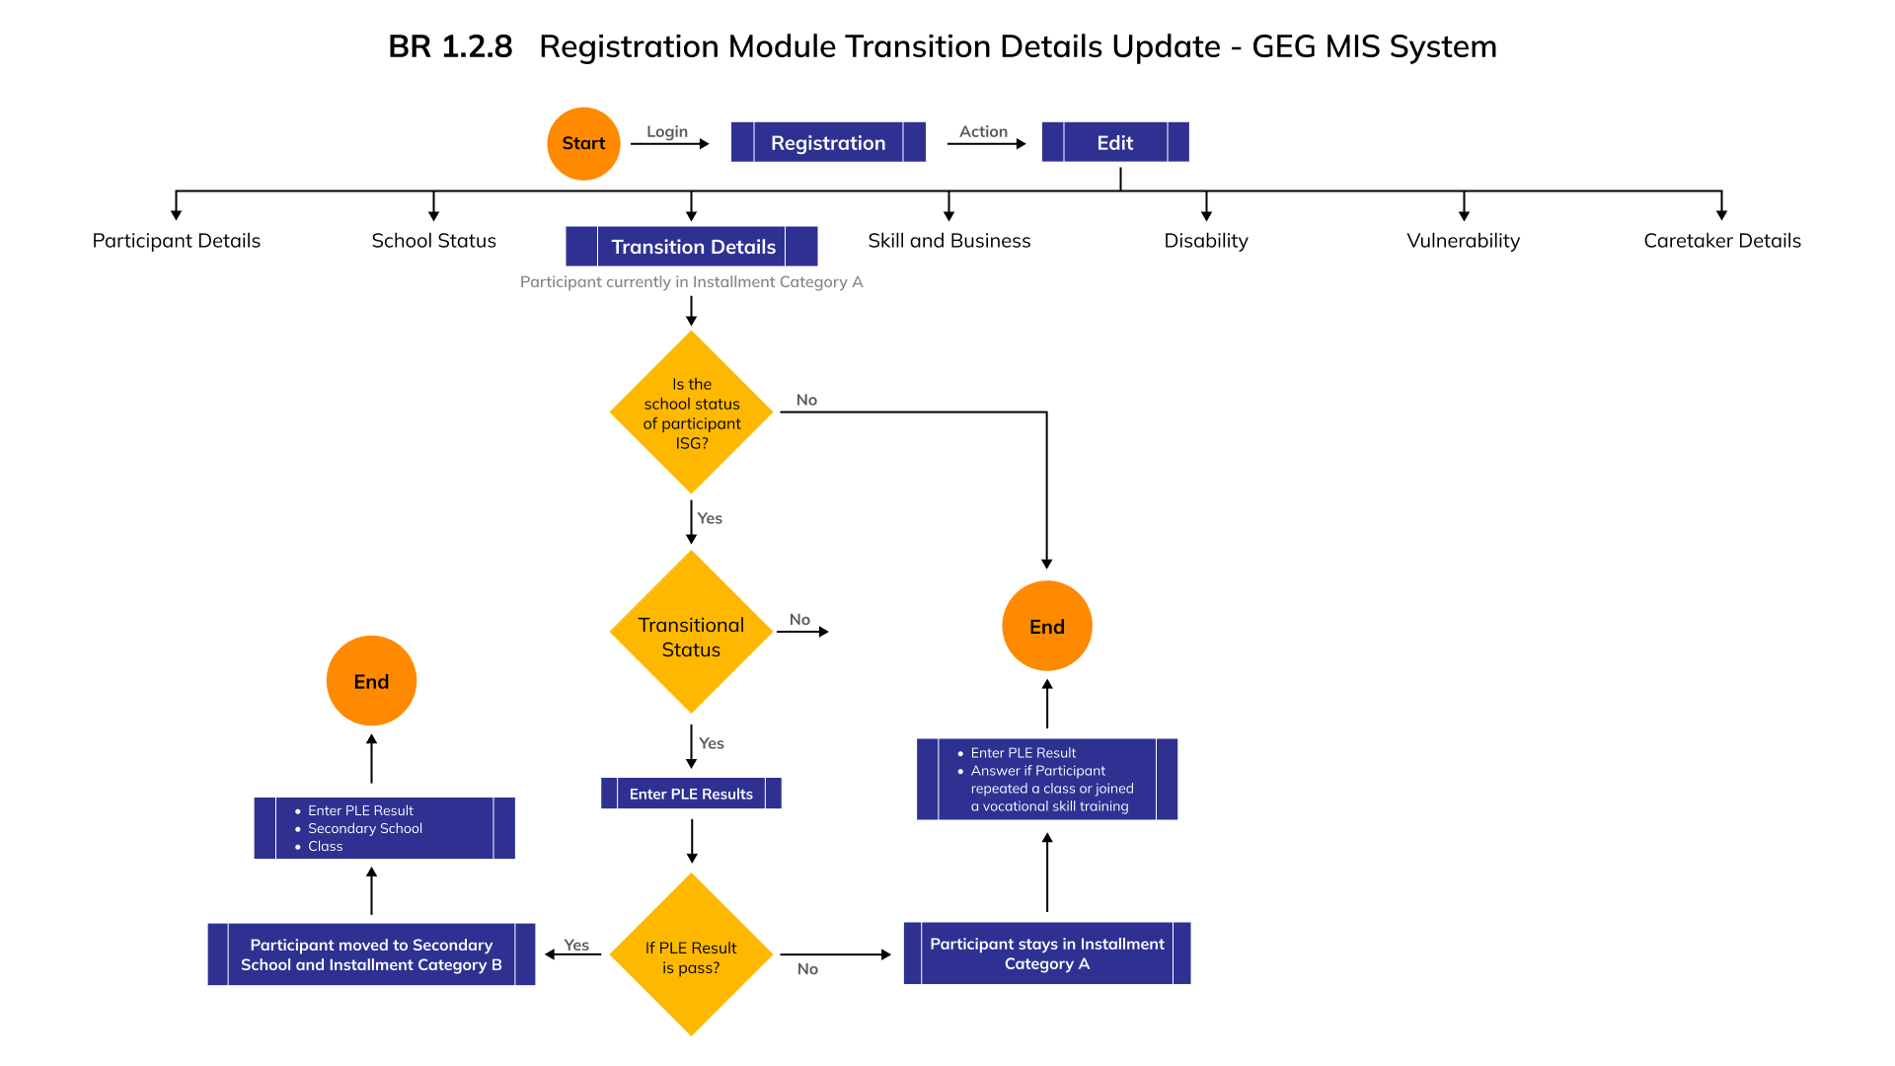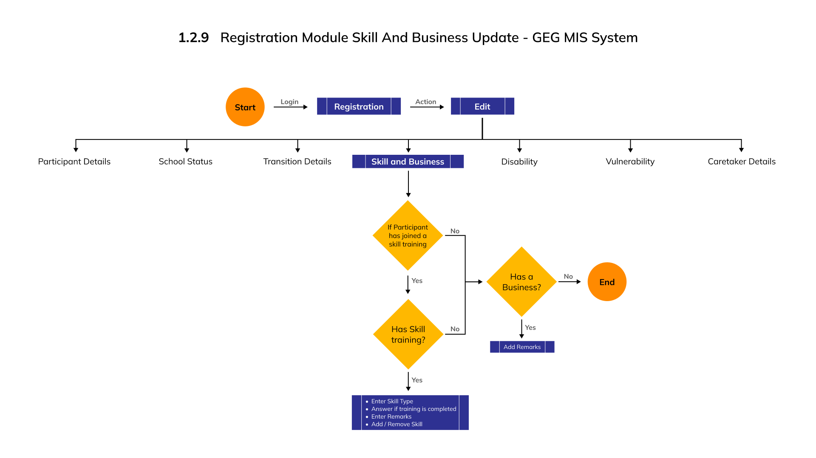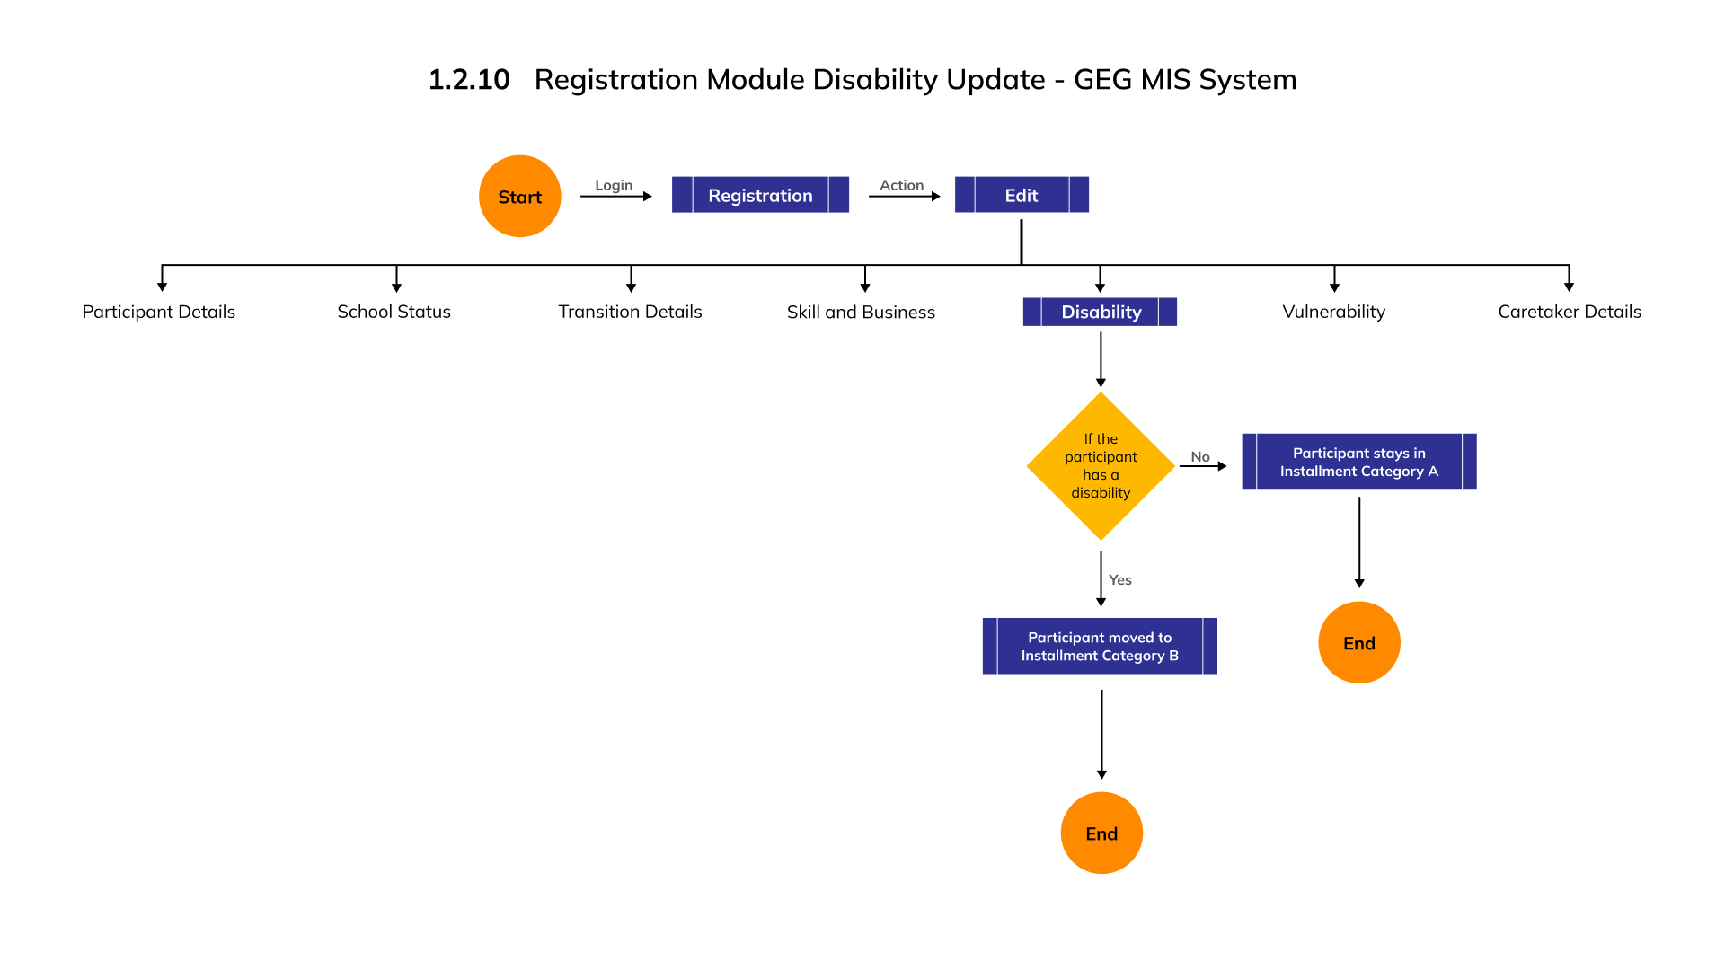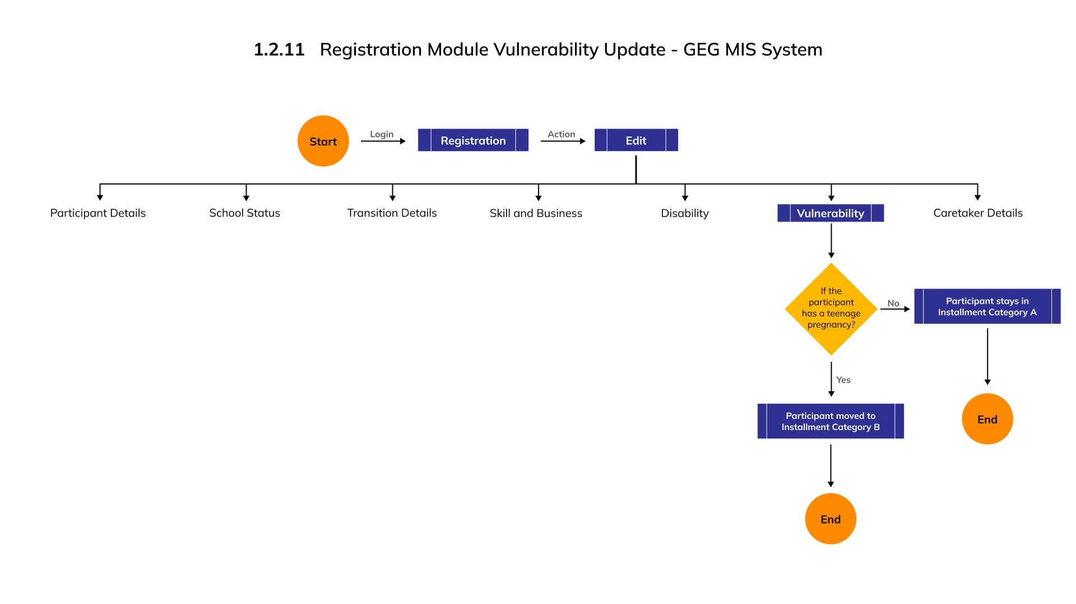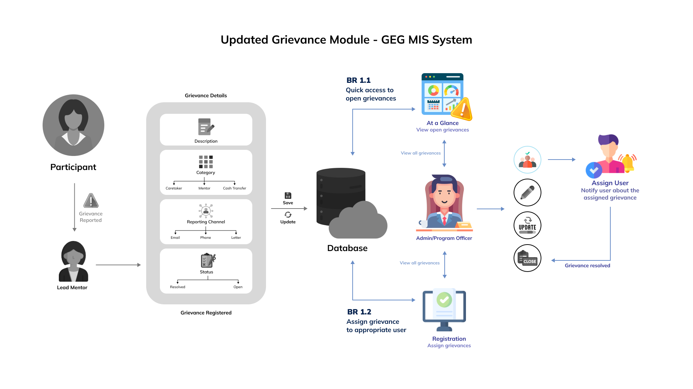

***END OF THE DOCUMENT***